D.C. Senior Advisory Coalition (S.A.C.) invites you to a
Budget & Advocacy Training:
Make Your Voice Heard

The DC City Council will begin hearings on the Mayor’s FY17 budget in April 2016.
Please join us to learn more about the budget process, citizen participation in the hearings, and learn how to tell your story and prepare your testimony.

Thursday, March 31, 2016
11:00 AM - 1:00 PM
Samuel J. Simmons NCBA Estates
2801 14th St. NW
Washington, DC 20009
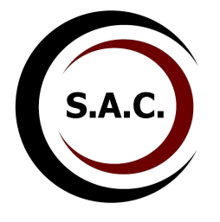
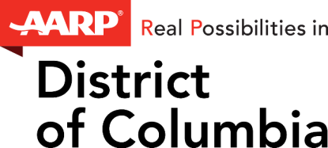

For more information or to RSVP, please contact saccoordinator@yahoo.com or call Alayna Waldrum at (916) 296-0651.

